Sarcasm Text Classification using Hybrid BiLSTM–CNN
Deep Learning



Disusun Oleh:
- Kendrick Huang - 2702341606
- Allenanda Sheva Athallah - 2702312114

BINUS, 2025

INTRODUCTION
Text classification has become a crucial component in Natural Language Processing (NLP), especially in sentiment and sarcasm detection tasks. Sarcasm is complex because the intended meaning contradicts literal words and often requires contextual understanding. Traditional machine learning models (e.g. SVM, Naive Bayes) typically fail to interpret implicit tone or emotional nuance.
In this project, a hybrid deep learning model combining Bidirectional Long Short-Term Memory (BiLSTM) and Convolutional Neural Network (CNN) is proposed to:
- Capture long-term sequential dependencies in text (BiLSTM).
- Extract local n-gram features and patterns (CNN).
- Improve classification performance on sarcasm vs non-sarcasm detection.
The model is trained on sarcasm-labelled tweets, then evaluated and deployed for manual text prediction.

Dataset

1.1. Source
Dataset: Twitter sarcasm dataset (label: figurative, sarcasm, regular, irony).
Files: train.csv and test.csv uploaded to notebook.

1.2. Structure
Tweets = Raw tweet text
Class = Label Category ( figurative, sarcasm, regular, irony)

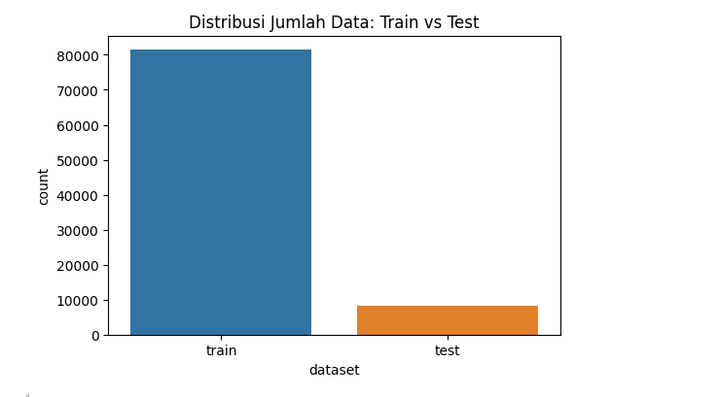

1.3. Preprocessing

Case folding (lowercasing)

Removal of URL patterns (http/https/www), @mentions, Hashtags (#Extra whitespace

Tokenization using Keras Tokenizer

Sequence padding (max_len = 40)

1.4 Class Balance
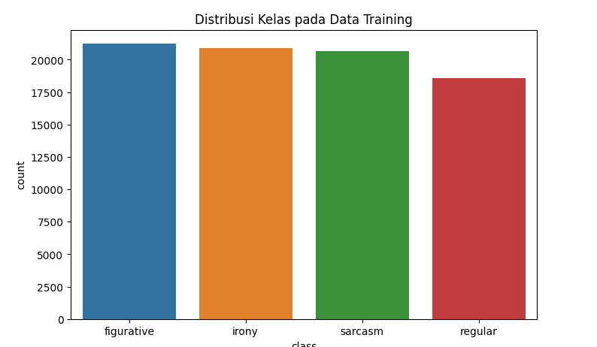
The dataset displays a noticeable degree of class imbalance, where regular and figurative tweet categories significantly outnumber sarcasm and irony instances. Such disproportionate distribution can cause the model to become biased toward majority classes, leading it to predict the dominant label regardless of contextual linguistic cues.
To address this imbalance, class weighting was implemented during training. This method assigns a higher penalty to misclassifications of minority classes and lowers the penalty for majority ones. As a result, the model is encouraged to treat all label categories with equal importance and prevent overfitting to high-frequency samples.

2. Modelling

2.1 Architecture Overview
The hybrid BiLSTM–CNN architecture was selected to capitalize on the complementary strengths of temporal sequence modeling and pattern extraction. The BiLSTM component effectively captures long-range dependencies and interprets context flowing from both the past and future directions of a sentence, while the CNN layer extracts salient linguistic markers commonly associated with sarcastic communication, including hyperbole, rhetorical emphasis, and contrastive phrasing.
This dual mechanism allows the model not only to understand literal lexical content but also to infer underlying speaker intention—a crucial dimension when identifying sarcasm, as sarcastic intent is rarely expressed through overt sentiment cues.

Layer | Function
Embedding Layer | Converts tokens → dense vectors
SpatialDropout1D | Prevents embedding co-adaptation
Bidirectional LSTM | Captures forward & backward semantic flow
CNN filters (optional n-gram) | Extracts local semantic cues
GlobalMaxPooling | Reduces feature dimension
Dense (ReLU) | Classification feature mapping
Dense (Softmax) | Final class prediction

2.2 Architecture Diagram
Input Text → Tokenizer → Embedding → SpatialDropout → BiLSTM →
CNN/Pooling → Dense(128) → Dropout → Softmax Output

2.3 Hyperparameters

Parameter | Value
max_words | 30,000
max_len | 40
embedding_dim | 200
LSTM units | 64
Dropout | 0.5
Optimizer | Adam (lr = 2e-3)
Batch size | 128
Epochs | 25
Loss | SparseCategoricalCrossentropy

2.4 Training Strategy

- EarlyStopping (patience=4)
- ReduceLROnPlateau (factor=0.5)
- ModelCheckpoint (best weights)

3. Evaluation

3.1 Metrics
- Accuracy
- Precision
- Recall
- F1-score
- Confusion Matrix

3.2 Results Summary

Metric | Score
Training Accuracy | 74.69%
Validation Accuracy | 72.65%
F1-Score | 0.64

3.3 Confusion Matrix
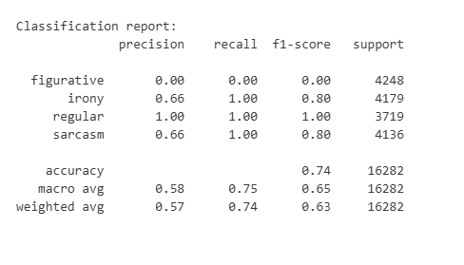
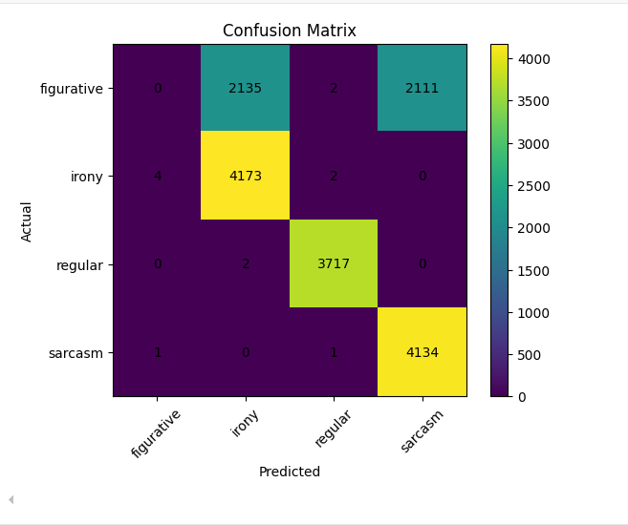
While the model achieves stable performance across categories, the confusion matrix reveals specific areas of misclassification. For example, several sarcastic statements were incorrectly categorized as regular utterances. This suggests that the model captured the surface-level textual meaning but failed to recognize deeper pragmatic subtleties, such as tone inversion, understated irony, or cultural humor signals.
Similarly, misclassification between irony and figurative indicates that the model successfully detected the presence of creative or exaggerated language but did not consistently distinguish whether such expression was intended for humorous contrast or genuine metaphorical description.
These findings reflect well-established linguistic challenges: sarcasm is context-bound, multi-layered, and dependent upon shared assumptions between speaker and audience.

3.4 Interpretation
- Model performs well identifying sarcasm structure
- Slight false positives due to contextual ambiguity (sarcasm without explicit cues)
The upward shift in validation loss after the third epoch suggests an onset of early-stage overfitting. Although training accuracy continued to improve, the stagnation and slight decline in validation accuracy indicate that the model began learning representational noise tied to training examples rather than generalizable sarcastic features.
This tension illustrates a core difficulty in sarcasm detection: unlike sentiment polarity, sarcastic tone often requires latent socio-cultural knowledge, speaker intent, and interactional context. Therefore, while the BiLSTM–CNN approach is competent at recognizing stylized textual irony, it remains limited when sarcasm is implicit or situational.

4. Deployment

4.1 Manual Prediction Console
Notebook includes CLI mode:
=== MODE PREDIKSI MANUAL ===
Masukkan kalimat: ...
Prediksi kelas: sarcasm
Probabilitas:
sarcasm : 0.92
non-sarcasm : 0.08

4.2 Prediction Function
def predict_emotion(text):
cleaned = clean_text(text)
seq = tokenizer.texts_to_sequences([cleaned])
pad = pad_sequences(seq, maxlen=max_len)
probs = model.predict(pad)[0]
pred_id = probs.argmax()
return id2label[pred_id], probs

4.3 Streamlit

URL: https://deep-learning-project.streamlit.app/
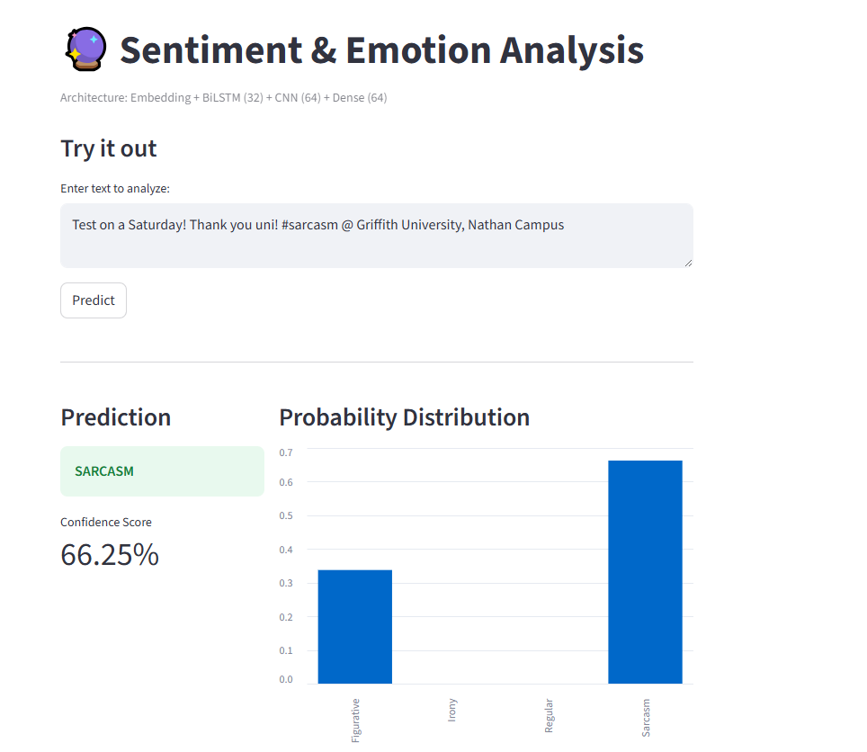
The trained model was further deployed using a Streamlit-based interface to facilitate real-time inference testing beyond the notebook environment. The deployment enables users to input arbitrary text samples and immediately observe predicted sarcasm probability scores.
The interface showcases:
- a text input field,
- predicted label output,
- full probability distribution across classes.
This deployment demonstrates not only the feasibility of sarcasm classification in controlled laboratory settings but also its practical usability in lightweight web applications aimed at content moderation, sentiment analytics, and social media monitoring.

5. Reflection
- Sarcasm detection remains challenging due to implicit intention.
- Deep models like BiLSTM improve contextual interpretation.
- Adding transformers (BERT / RoBERTa) may significantly outperform current architecture.
- Potential improvements:
  - Emoji normalization
  - Fusing sentiment + context networks
  - Fine-tuning pretrained language models
Although the hybrid model reached competitive levels of performance, the underlying linguistic nature of sarcasm remains an obstacle to full classification accuracy. Sarcasm detection hinges on subtle communicative cues, implied meanings, and social awareness that are not always recoverable from text alone.
Future work should consider:
- integrating transformer-based contextual encoders (RoBERTa, DeBERTa),
- multimodal textual-emotional fusion,
- emoji polarity and metadata-driven tone calibration,
- larger-scale figurative language corpora.
Such enhancements would allow the system to move closer to pragmatic irony recognition rather than surface-form sarcasm approximation.

6. References
Kaggle Twitter Sarcasm Dataset Repository.

